Image-Based Crack Identification and Width Estimation: A Review from Classical OpenCV Pipelines to Deep Learning
PATEL MAN VISHNUBHAI. | MCA(CA)/ICA | PP SAVANI UNIVERSITY

Abstract
Cracks are early indicators of deterioration in concrete and pavement, and their width is the quantity most closely tied to severity. Manual measurement with a comparator gauge is slow and subjective, which has driven research into image-based identification and measurement. This paper reviews that research from fundamentals to current methods, organized along the pipeline of an OpenCV-based system: image acquisition and preprocessing, segmentation, quantification of length, area, orientation and width, pixel-to-millimeter calibration, deep-learning segmentation and datasets, and evaluation.
The review finds that classical thresholding and morphology remain a reproducible baseline, that skeleton-based width methods improve when measurement direction is corrected using crack boundaries, that laser and 3D references are the main verified routes to millimeter units, and that the most complete systems combine deep segmentation with geometric measurement. The main open problems are the lack of an agreed width definition, incomparable accuracy metrics, handling of branching cracks, public datasets with millimeter ground truth, and field validation. A reference architecture for an OpenCV-based system is proposed.
Keywords: crack detection, crack width estimation, OpenCV, image processing, skeletonization, camera calibration, deep learning, structural health monitoring

1. Introduction
Cracks are among the earliest visible signs of deterioration in concrete, masonry and pavement. They let water, chloride and carbon dioxide reach reinforcement, they reduce stiffness, and their pattern often reveals the cause of damage. Inspection therefore has two jobs: finding cracks and describing them well enough to decide what to do. Manual inspection does both through an inspector's eye and a hand-held crack-width comparator gauge. Mohan and Poobal (2018) point out that this approach depends on the specialist's experience and lacks objectivity in quantitative analysis, and Araya-Letelier et al. (2021) add that the gauge is slow, subjective and error-prone, because it may not be aligned with the crack's orientation.
Image-based inspection offers a repeatable alternative. A camera records the surface, and software extracts the crack and measures it. Among the available tools, OpenCV is attractive for research and prototypes because the whole classical pipeline (color conversion, filtering, contrast enhancement, thresholding, morphology, contour analysis, distance transforms) exists as optimized library functions that run on ordinary hardware without training data.

1.1 Problem statement
Crack detection and crack measurement are different problems, and the literature treats them unequally. Detection answers a yes or no question for an image or a pixel. Measurement must return numbers (width, length, area, orientation) in physical units, with a stated error. Araya-Letelier et al. (2021) observe that segmentation has advanced much faster than width analysis and that accurate image-based width estimation remains an open problem. Nyathi et al. (2023) make a related point about units: much research addresses detection, but accurate quantification of width in millimeters is a gap, because current methods either report pixels or need markers attached to the surface.

1.2 Objectives and contributions
This paper reviews image-based crack identification and width estimation from first principles to current research. It aims to:
- explain each stage of a crack-measurement pipeline in a way that can be implemented with OpenCV;
- compare classical image-processing methods with deep-learning methods on what each actually delivers;
- examine width-estimation algorithms and the calibration step that converts pixels to millimeters;
- identify gaps that matter for building and validating a practical system.
The review is organized as a pipeline. Sections 2 and 3 give background and scope. Sections 4 to 7 follow the image through preprocessing, segmentation, quantification and calibration. Section 8 covers datasets and deep learning, Section 9 covers evaluation, and Sections 10 and 11 compare methods, summaries gaps and propose a reference architecture.

2. Fundamentals of Cracks and Crack Measurement

2.1 Crack types and causes
Surface cracks in concrete arise from several mechanisms: plastic and drying shrinkage, thermal movement, flexural and shear loading, differential settlement, corrosion of embedded steel and freeze-thaw action. In pavements, cracks are usually grouped by pattern into longitudinal, transverse and interconnected (alligator) cracking. The pattern matters because it points to the cause. Qayyum et al. (2023) note that the angle, width and length of a crack allow the cause of propagation and the extent of damage to be inferred, and rehabilitation to be suggested.

2.2 Which measurements matter
A useful measurement system reports a small set of geometric quantities. Table 1 summarizes them and what each is used for.

Quantity | Definition | Why it is measured
Width (local and maximum) | Distance across the crack, perpendicular to its direction | Severity classification; compliance with allowable limits
Length | Path length along the crack | Extent of damage; crack density
Area | Number of crack pixels converted to physical area | Crack ratio; average width as area divided by length
Orientation | Angle of the crack relative to a reference axis | Likely cause (flexural, shear, shrinkage)
Pattern or type | Longitudinal, transverse, diagonal, random | Diagnosis and repair choice
Table 1. Geometric quantities in image-based crack assessment.

2.3 Why width is the hard quantity
Width is the number most closely tied to severity, yet it is the least well defined. A real crack is not a parallel-sided slot: it curves, branches, and varies in width along its path. Several different definitions are in use. One takes a single average width as crack area divided by crack length. Other measures the minimum distance between the two crack edges. A third works point by point, taking a skeleton point and measuring across the crack in the direction normal to the skeleton. A 2025 study of an Edge-Orth Boundary method describes the lack of a clear definition of width as the central difficulty of image-based measurement, and an Engineering Structures paper on backbone double-scale features notes that sample points used to describe crack width are often chosen subjectively by experimenters, which obscures the ground truth.
Severity thresholds also differ between jurisdictions. Li et al. tabulate pavement-engineering standards from five countries and show that their width classes do not coincide, so a system should report the measured width and leave classification to the user's governing standard.

2.4 Scale of the measurement problem
The range of widths a system must handle is wide. The SDNET2018 dataset, built from bridge decks, walls and pavements, contains cracks as narrow as 0.06 mm and as wide as 25 mm (Draftsman et al., 2018). Araya-Likelier et al. (2021) report detecting real cracks as small as 0.15 mm. Hairline cracks may therefore span only a few pixels in a normal photograph, so resolution, distance to the surface and sub-pixel handling decide whether the narrowest cracks can be measured at all.

2.5 From a single image to a monitoring framework
Measurement is often only one part of a larger workflow. Chen and Hutchinson (2010) proposed an image-based framework with three parts: determining damage occurrence from time-series images, localizing the damage in each frame, and quantifying its geometry. This view, detect then localize then quantify, is the structure followed by most later systems.

3. Review Methodology and Source Coverage
The review starts from a curated reading list of 32 entries on crack identification, segmentation, geometric measurement, calibration, datasets and deep learning. Four entries repeat earlier ones and six are search topics, leaving 22 distinct publications. Publisher or repository records of the central papers were opened and their abstracts read. These records were then supplemented by additional papers found while checking claims, mainly on width algorithms, laser calibration and deep-learning measurement.
Two rules govern what the text says about a source. First, a paper's results are reported only where its record states them, and they are quoted as that paper's own figures on its own data. Second, for papers whose records could not be opened, the text states only their listed topic, and the reference list marks them for verification. Methods are grouped by the stage of the pipeline they serve, not by publication date, so that a reader can move directly from a problem to the evidence on it.

Pipeline stage | Main issues examined | Representative sources
Preprocessing | Noise, uneven lighting, low contrast | Mohan and Poobal (2018); Liu et al. (2014)
Segmentation | Thresholds, morphology, tree and seed methods | Zou et al. (2012); Liu et al. (2014)
Quantification | Length, area, local width | Araya-Likelier et al. (2021); Qayyum et al. (2023)
Calibration | Pixel to millimeter conversion | Nyathi et al. (2023, 2024)
Datasets and deep learning | Benchmarks, pixel-level segmentation | Dorafshan et al. (2018); Liu et al. (2019)
Reviews | Trends, gaps, evaluation | Deng et al. (2022); König et al. (2022)
Table 2. Coverage of sources by pipeline stage.
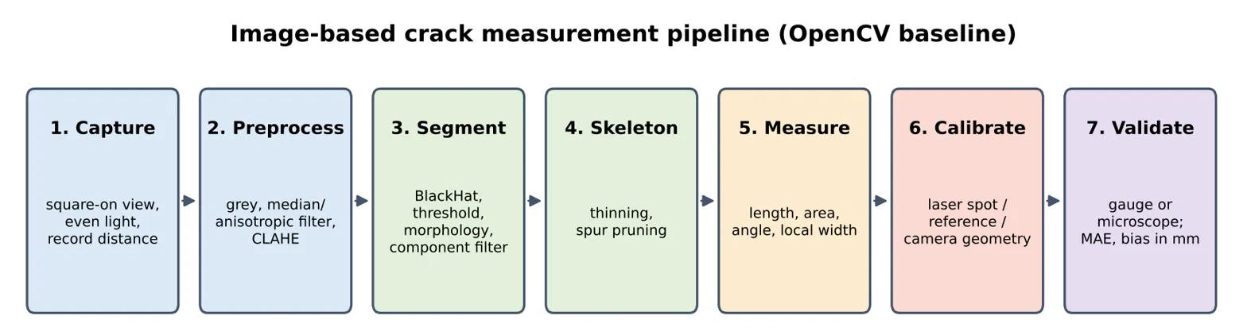
Figure 1 : The pipeline followed in this review is shown in Figure 1.

Limitations of this review
The review is not a systematic search with a registered protocol, and it does not rank methods. Reported accuracies come from different materials, image sets and metrics, so they cannot be compared directly. Where this matter, the text says so.

4. Image Acquisition and Preprocessing
Mohan and Poobal (2018) describe the generic architecture of image-based crack detection as acquisition, preprocessing, segmentation, feature extraction and detection. Everything downstream depends on the first two stages, so errors introduced here cannot be recovered later.

4.1 Acquisition
Three acquisition choices directly limit measurement accuracy.
- Resolution and distance. The physical size of one pixel equals the distance covered by the image divided by its pixel count. A crack narrower than a pixel or two cannot be measured reliably, so camera resolution and stand-off distance set the smallest measurable width.
- Viewing angle. Measurement assumes the camera looks perpendicular to the surface. Oblique views change the pixel scale across the image and distort widths.
- Lighting. Araya-Letelier et al. (2021) note that the incident angle of light can cast shadows that lead to errors in crack detection, and that some materials produce false crack regions. Diffuse, even lighting reduces both problems.

4.2 Color conversion and noise reduction
Most classical crack methods work on a single-channel grey-scale image, since cracks are distinguished mainly by being darker than their surroundings. Concrete texture, pores and stains create noise of similar scale, so filtering is needed before thresholding. Median filtering is the most frequently cited choice in the review by Mohan and Poobal (2018), because it removes small isolated noise while keeping edges. Liu et al. (2014) go further and use the difference between the image and its median-filtered version to isolate thin dark structures. Araya-Likelier et al. (2021) use anisotropic smoothing, which smooths along structures rather than across them and so protects crack edges, an important property when the edge position determines the measured width.

4.3 Illumination correction and contrast enhancement
Uneven lighting is a leading cause of thresholding failure, because a single global threshold cannot suit both a bright and a shadowed region. Two operations are widely used for this in OpenCV workflows.
- CLAHE (contrast-limited adaptive histogram equalization) equalizes contrast within small tiles and limits the amplification of noise. It raises the local contrast of a faint crack without over-brightening smooth areas.
- Morphological Black Hat subtracts the original image from its morphological closing. The result highlights dark features smaller than the structuring element, which is exactly what a thin crack is. The kernel must be larger than the widest crack of interest, otherwise wide cracks are partly removed.
The combination of CLAHE followed by Black Hat is a common recommendation for dark cracks on lighter surfaces. This review did not find a single verified paper dedicated to that exact combination, so it should be treated as engineering practice and tuned on the target images, not as an established result.

Operation | OpenCV function | Purpose | Main risk
Grey conversion | cvt Color | Single channel for analysis | Loses color cues that separate stains from cracks
Median filter | median Blur | Remove salt-and-pepper noise | Can erase hairline cracks if the kernel is too large
Gaussian or bilateral filter | Gaussian Blur, bilateral Filter | Smooth texture | Gaussian blurs edges; bilateral is slower
CLAHE | createCLAHE | Local contrast gain | Amplifies surface texture if the clip limit is high
Black Hat | morphologyEx with BLACKHAT | Highlight thin dark structures | Kernel size must match the crack width range
Table 3. Common preprocessing operations for crack images.

4.4 Key point for measurement
Preprocessing should be judged by whether it preserves the position of crack edges. A filter that gives a cleaner mask but moves the edge by one pixel changes the width of a 3-pixel crack by a third.

5. Crack Segmentation with Classical Methods
Segmentation converts the enhanced image into a binary mask in which crack pixels are 1 and everything else is 0. Munawar et al. (2021) describe classical image-processing detection as methods that need no model training and use filters, morphological analysis, statistical methods and percolation techniques. Because every measurement in Sections 6 and 7 starts from this mask, its quality sets the ceiling for width accuracy.

5.1 Global and adaptive thresholding
Thresholding labels a pixel as crack if it is darker than a limit. Otsu's method chooses one global limit automatically by maximizing the separation between two intensity classes. It works well when lighting is even, but a crack occupies only a tiny fraction of the pixels, so the histogram is dominated by background and the chosen limit can be unstable. Adaptive thresholds compute a separate limit for each neighborhood and cope better with shadows.
Liu et al. (2014) give a clear example of an adaptive pipeline. They subtract a median-filtered image, binarise with the local Niblack method, and introduce an optimal filter size index that selects the window sizes for the median filter and Niblack method without distorting the crack. The window size is an important parameter: too small and crack interiors break up, too large and thin cracks vanish. Their procedure was verified on a concrete reaction wall carrying cracks of several widths and patterns, with sub-millimeter widths calculated with high accuracy.
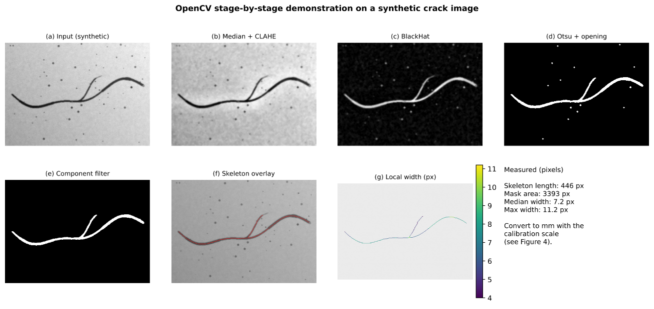
Figure 2 : illustrates the main stages on a synthetic crack image.

5.2 Morphological clean-up
A raw threshold mask contains speckle, small gaps and non-crack blobs. Morphological opening removes isolated specks, closing bridges small gaps, and connected-component analysis removes regions that are too small or too compact to be cracks. Cracks are long and thin, so filtering components by elongation, or by skeleton length compared with area, is a robust rule. Over-aggressive closing is harmful for measurement because it fills the crack and narrows the apparent gap between its edges, while over-aggressive opening can thin the mask.

5.3 Tree-based and seed-based detection
Pavement images pose a harder problem, because cracks are faint, shadowed and surrounded by lane markings. Zou et al. (2012) introduced Crack Tree, which detects cracks in pavement images and represents complex crack structures as trees. It was evaluated on 206 real pavement images and was reported to outperform several existing methods. Its image set later became a standard benchmark for crack-detection models. A related seed-based approach for pavement images masks lane markings, corrects the non-uniform background, detects crack seeds on a grid, connects them with a Euclidean minimum spanning tree and removes small branches by path length; it was tested on 105 pavement images (Texas Department of Transportation Crack system data). These methods show a useful idea for any system: first find strong local evidence of a crack, then connect it, which suppresses false positives better than thresholding alone.

5.4 Strengths and limitations

Method family | Strengths | Limitations
Global threshold (Otsu) | Fast, no parameters, simple in OpenCV | Fails under uneven lighting; unstable on tiny crack fractions
Adaptive threshold | Handles shadows and local contrast | Window size must be tuned
Morphology and component filtering | Removes speckle; enforces thin shape | Can fill or thin cracks if kernels are large
Tree and seed methods | Connect fragments; suppress noise | More parameters; tuned for pavement
Edge detection | Locates boundaries | Sensitive to texture; gives broken edges
Table 4. Classical segmentation approaches.

5.5 Where classical segmentation struggles
The SDNET2018 authors built their dataset to include shadows, surface roughness, scaling, edges, holes and background debris (Dorafshan et al., 2018). These are exactly the conditions under which classical thresholding produces false cracks, which is the main reason deep-learning segmentation, discussed in Section 8, has become common.

6. Crack Quantification: Area, Length, Orientation and Width
Once a clean binary mask exists, geometry is extracted from it. The standard intermediate object is the skeleton, a one-pixel-wide centerline obtained by thinning the mask. Length, orientation and local width are all read from the skeleton and the mask boundary together.

6.1 Area and length
Crack area is the count of mask pixels multiplied by the physical area of one pixel. Crack length should follow the skeleton path, not the straight line between endpoints. Qayyum et al. (2023) measured both and found the true path length to be 14.69% greater than the endpoint length for their cracks, and they conclude that irregular shape must be considered when length is calculated. Their method, which combines a pre-trained convolutional network with image processing, reported relative errors of 2.19% for crack angle, 14.88% for width and 1.11% for endpoint length. The much larger width error compared with length error illustrates a general pattern: length and angle are forgiving, width is not, because a one-pixel edge error is a large fraction of a thin crack.

6.2 Orientation
Orientation can be taken from the skeleton direction or from the principal axis of the mask. Araya-Likelier et al. (2021) estimate an orientation related to the crack's curvature and use the angle normal to it, which allows width to be measured across the crack, not along an arbitrary image axis.

6.3 Width: the central problem
The simplest width estimate is the average width, defined as crack area divided by crack length. It is easy to compute but hides local variation and cannot report the maximum width, which is usually what governs severity. Point-by-point methods are preferred. The most common starting point is a distance transform of the mask: at each skeleton pixel, the distance to the nearest background pixel is roughly half the local width, so width is approximately twice that value. This is quick in OpenCV but has two known weaknesses. The result is quantized to whole pixels, and near curves and junctions the nearest background pixel need not lie in the direction normal to the crack.
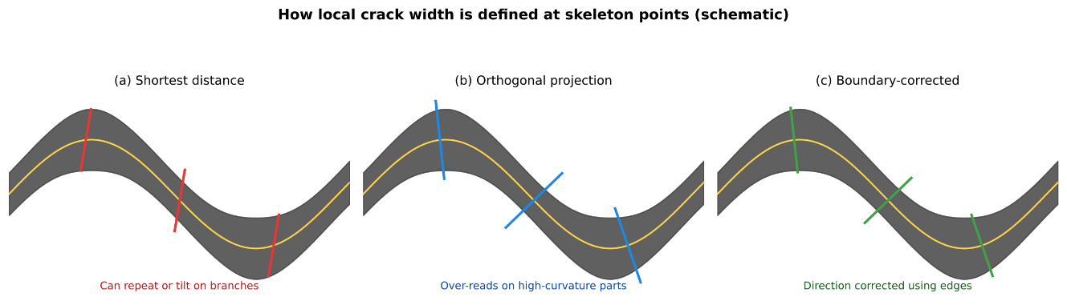
Figure 3 : compares how the main width methods place the measurement line.
Several refinements address these weaknesses.
- Normal-line methods. Liu et al. (2014) decompose the crack into skeleton and edges and compute width along a 4-connected normal line, chosen according to the orientation of the local skeleton. They also produce a crack-width map over the image to show where wide sections lie.
- Stabilized central points. Araya-Letelier et al. (2021) use anisotropic smoothing, segmentation and k-means adjustment of central points to estimate width and orientation together. They report that the method discards false cracks and detects real cracks as small as 0.15 mm regardless of lighting, tested on fiber-reinforced earthen materials.
- Shortest-distance and orthogonal projection. Shortest-distance methods measure the minimum gap between the two edges; orthogonal projection measures perpendicular to the skeleton direction. A hybrid method for pavement cracks combines them by choosing the edge pair that is both close and near the orthogonal direction. On synthetic cracks it reported an average absolute deviation of 1.769 pixels and a correlation of 0.956, improving on the shortest method by reducing repeated measurements and on orthogonal projection by reducing overestimation on non-parallel and high-curvature cracks.
- Boundary-corrected projection. Li et al. developed the Orth Boundary algorithm, which uses boundary and skeleton directions to follow crack propagation. Across five width methods it reported average accuracy from 76.01% for the skeleton shortest distance to 90.10% for Orth Boundary, with orthogonal projection at 88.07%. A 2025 Edge-Orth Boundary study then combined Orth Boundary with the edge shortest distance, added skeleton pruning and a dilation-based intersection removal step, and reported the smallest error against orthogonal projection, OrthoBoundary and edge shortest distance on real and synthetic cracks.
Two further 2025 papers, on a neighborhood shortest distance method (Engineering Structures) and a segment-based adaptive neighborhood orthogonal projection method for complex branching cracks (Results in Engineering), continue this line. Their full records were not opened for this review, so only their stated purpose, width estimation on complex crack geometry, is reported.

6.4 Practical points for implementation
- Prune short skeleton spurs before measuring, because spurs create false width samples.
- Treat junctions separately. OrthoBoundary excludes crack intersections from measurement, and the Edge-OrthoBoundary study adds a dedicated intersection-removal step.
- Report both the maximum and a robust statistic such as the median or a high percentile, not only the mean.
- Prefer sub-pixel edge locations where possible, since a one-pixel error on a 3-pixel crack is a 33% error.

7. Calibration: Converting Pixels to Millimeters
A width in pixels has no engineering meaning until the size of one pixel on the surface is known. This step is the least glamorous in the pipeline and the one where many systems quietly fail. Nyathi et al. (2023) state the problem directly: current methods either measure in pixels or require scales or markers to be attached to the measured surface, which can be a safety hazard in hard-to-reach places.

7.1 Pixel size from camera geometry
If the camera looks perpendicular to the surface, the size of one pixel on the surface follows from the camera model:
$$s = \frac{d p}{f}$$
where s is the surface size of one pixel, d the distance from the camera to the surface, p the sensor pixel pitch and f the focal length. This is accurate only if d is measured accurately and the view is square-on, so it is usually combined with a physical reference.

7.2 Reference objects and laser references
The common alternatives are summarized in Table 5.
Approach | How it works | Strength | Limitation
Scale or marker in the scene | A ruler or target of known size is imaged with the crack | Simple, direct | Must be placed on the surface; awkward at height
Object-distance (camera model) | Pixel size computed from distance, focal length and pixel pitch | No contact | Needs accurate distance; assumes square-on view
Projected laser spot | A laser of known diameter is projected onto the surface | No contact; scale is in the image | Extra hardware; spot must be visible and measured
Image plus 3D data | Scale from 2D to 3D correspondences or LiDAR | Handles non-flat surfaces | Needs 3D sensing and registration
Table 5. Calibration approaches.

Nyathi et al. (2023) project a circular laser beam onto the concrete surface. The image is pre-processed, segmented and skeletonized to obtain width in pixels, and the relationship between laser diameter and camera distance converts pixels to millimeters. They validated the method in the laboratory with two cameras of different resolutions, and note that attaching the laser to a drone could make inspections of low-accessibility areas safer. They also point out that millimeter results can be compared directly with allowable crack widths in international standards, which are expressed in metric units. In a follow-up, Nyathi et al. (2024) combine laser calibration with deep-learning classification and U-Net segmentation, and report a mean absolute width error of 0.16 mm.
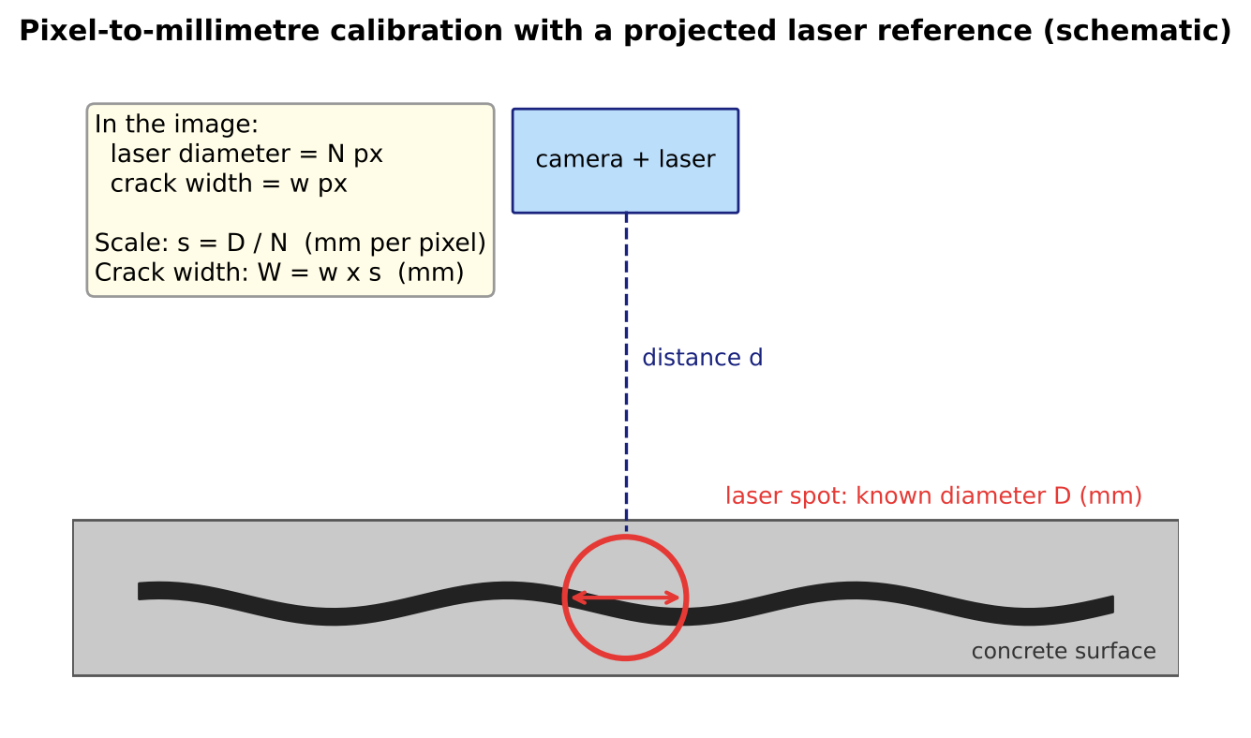
Figure 4 : Pixel-to-millimeter conversion with a laser spot
A comparison on bridge crack images found that an object-distance method gave more accurate widths than a ruler-based scale method (Concrete Crack Identification and Image Mosaic Based on Image Processing, 2019), which supports using camera geometry where a physical reference is awkward to place.

7.3 Using three-dimensional information
Where surfaces are not flat, a single scale factor is inadequate. Krefft and Heegner (2025) combine neural-network crack segmentation with 3D geometric data from masonry surfaces. They measure width in the images using the segmentation masks and a scaling factor derived from 2D to 3D correspondences, and compute length with a graph model whose longest continuous path is found with Dijkstra's algorithm. A 2024 study by Alamdari and Ebrahimkhanlou goes further: a convolutional network finds candidate cracks, a robot then positions a high-resolution laser scanner over them, and 3D point cloud registration fuses the scans with a LiDAR map of the surroundings. They compared the results with vision-based methods and with readings from a transparent crack-width ruler. A 2025 preprint on 3D modelling with Segment Anything refinement and visual-inertial LiDAR fusion validated width against microscope readings taken about every 10 mm along cracks and reports sub-millimeter accuracy. These approaches trade simplicity for accuracy on real structures.

7.4 Implications
- A system should store the calibration method and its assumptions with each measurement.
- Uncertainty in the scale factor adds directly to width error, so it should be validated independently of the width algorithm.
- Camera distance and angle should be recorded or controlled at capture time.

8. Datasets and Deep Learning
Deep learning enters the pipeline at two points: deciding whether an image or patch contains a crack (classification), and labelling every pixel as crack or not (segmentation). Both depend on annotated data, and the type of annotation decides what can later be measured.

8.1 Datasets
Dataset | Content | Label type | Suitability for width work
SDNET2018 | Over 56,000 images of concrete decks, walls and pavements; cracks 0.06 to 25 mm; shadows, debris, holes | Crack or no crack per 256 by 256 image | Detection benchmark; no pixel masks or millimeter ground truth
Deep Crack benchmark | Manually annotated crack images from varied scenes | Pixel-level | Segmentation training and testing
Crack Tree set | 206 pavement images, 800 by 600 pixels | Pavement benchmark | Pavement detection
EdmCrack600 | 600 pixel-annotated road images from an action camera | Pixel-level | Segmentation
Table 6. Representative crack datasets.
SDNET2018 was released with a benchmark classifier based on the Alex Net architecture (Dorafshan et al., 2018). The statement that it lacks pixel masks is an inference from its image-level labelling, not a criticism by its authors, but it matters: a model trained on such labels can find cracks, yet it cannot by itself supply boundaries from which width is computed. Details for the Crack Tree and EdmCrack600 sets are taken from a 2025 YOLOv8 road-crack study that reviews public pavement datasets.

8.2 Segmentation networks
Liu et al. (2019) proposed Deep Crack, a hierarchical convolutional network that combines extended fully convolutional networks with deeply supervised nets. Instead of relying only on the last convolutional layer, it learns and aggregates multi-scale and multi-level features from low layers to high layers, with direct supervision at every stage, and refines the output with guided filtering and conditional random fields. They also released an open annotated benchmark so that systems can be compared. A separate IEEE Transactions on Image Processing paper with the same name, by Zou et al. (2019), addresses pixel-level crack detection with hierarchical convolutional features; only its listed focus was available to this review. A later study builds on that pipeline with a SegNet-style encoder-decoder in which five feature maps are fused by concatenation and a 1 by 1 convolution to produce a crack probability map (Enhanced Hierarchical CNN study, 2019).
The reason multi-scale design matters is geometric. A crack is thin, so deep layers with large receptive fields find it but blur its edges, while shallow layers keep fine edges but see little context. Combining them gives a mask that is both correct and sharp, and sharpness is what width measurement needs.

8.3 Hybrid systems: deep segmentation with classical measurement
Most successful measurement systems do not ask a network for width directly. They use the network for the hard part, segmentation under clutter, and then apply geometry. Nyathi et al. (2024) use a custom convolutional network for classification and a U-Net for segmentation, then skeletonize the mask and convert width with laser calibration. They report 99.22% classification accuracy, 96.54% segmentation accuracy and a mean absolute width error of 0.16 mm. Qayyum et al. (2023) similarly pair a pre-trained network with image processing to obtain angle, width and length. These numbers come from separate datasets and metrics and are not comparable with each other.

8.4 Surveys and newer directions
König et al. (2022) review deep-learning crack analysis across classification, detection, segmentation and quantification, covering fully, semi and unsupervised approaches, the popular datasets and the metrics used, and they outline research gaps. Deng et al. (2022) review image-level detection, pixel-level segmentation and quantification, noting that earlier reviews focused on qualitative damage evaluation or segmentation and neglected categorization of quantitative assessment methods. A 2025 conference review identifies vision transformers as a newer alternative to convolutional networks for crack segmentation, though no individual transformer paper was verified here.

8.5 Trade-offs against classical methods
- Deep models handle shadows, texture and clutter far better, but need annotated images and may generalize poorly to a new material.
- Classical pipelines need no training and are transparent, so every intermediate image can be inspected, which helps when diagnosing measurement errors.
- Annotation quality limits width accuracy: a mask drawn one pixel too wide or narrow changes the measured width of a thin crack substantially. This is an inference from the geometry, and it is a reason to validate against independent measurements.

9. Evaluation Metrics and Validation Practice
A crack system must be evaluated at two separate levels: how well it finds the crack, and how well it measures it. Mixing the two hides the weakness that matters most in practice, since a method can score highly on segmentation and still measure width poorly.

9.1 Segmentation metrics
Segmentation is scored by comparing the predicted mask with a manual mask. Precision is the fraction of predicted crack pixels that are true crack, recall is the fraction of true crack pixels found, and the F1 score combines them. Intersection over union measures the overlap directly:
$$\text{IoU}=\frac{\left|P∩G\right|}{\left|P∪G\right|}$$

where P is the predicted mask and G the ground-truth mask. For thin structures these scores are very sensitive to a one-pixel shift of the boundary, so many studies allow a small tolerance band around the ground truth. König et al. (2022) list the datasets and the metrics used across the deep-learning literature, which is a useful starting point when choosing comparable measures.

9.2 Measurement metrics
Width and length are scored by comparison with reference values using errors in physical units:
$$\text{MAE}=\frac{1}{N}\sum_{i=1}^{N}{\left|\hat{w_{i}}-w_{i}\right|}$$

where the estimated width is compared with the reference width at each of N points. Studies also report relative error, correlation and average absolute deviation. Examples in the reviewed work include a mean absolute width error of 0.16 mm (Nyathi et al., 2024), relative errors of 14.88% for width and 1.11% for length (Qayyum et al., 2023), and an average absolute deviation of 1.769 pixels with a correlation of 0.956 on synthetic cracks (the hybrid pavement method). Bias, meaning the average signed error, should be reported as well, because a method that systematically overestimates width on curved cracks can still have a good correlation.

9.3 Sources of reference values
Reference widths come from four kinds of source, with different strengths.
Reference | Used by | Strength | Weakness
Crack-width comparator or ruler | Alamdari and Ebrahimkhanlou (2024) | Standard field tool | Subjective; alignment errors (Araya-Letelier et al., 2021)
Microscope readings at marked points | 3D LiDAR fusion preprint (2025) | Accurate, point-wise | Slow; needs matching to image locations
Synthetic cracks with known width | Hybrid pavement method; Edge-OrthoBoundary study | Exact ground truth | May not reflect real texture and noise
Manual measurement on images | Many studies | Cheap | Subjectivity in choosing sample points
Table 7. Reference measurements used for validation.

9.4 Recommended reporting
- Report error in millimeters, with the calibration error stated separately.
- Report bias and spread, not only a correlation.
- State the smallest crack width reliably measured, as Araya-Likelier et al. (2021) do with 0.15 mm.
- Evaluate on cracks with curvature and branching, not only straight cracks.
- Test under changed lighting, since shadows are a recurring cause of failure.
- Share the dataset or the protocol, so results can be compared.

10. Comparative Analysis of Reviewed Methods
Table 8 sets the verified studies side by side. Each result is that paper's own figure on its own data, so the table describes what was claimed and in what setting. It is not a ranking.

Study | Task | Method | Reported result | Material
Zou et al. (2012) | Detection | Crack-tree representation | Better than several existing methods on 206 images | Pavement
Liu et al. (2014) | Detection and width | Median-filter subtraction, Niblick, skeleton normal | Sub-millimeter widths with high accuracy | Concrete wall
Araya-Likelier et al. (2021) | Width and orientation | Anisotropic smoothing, k-means central points | Real cracks down to 0.15 mm | Fiber-reinforced earth
Li et al. (OrthoBoundary) | Width | Boundary and skeleton directions | 90.10% average accuracy against 76.01% to 88.07% for four other methods | Pavement
Hybrid pavement method | Width | Shortest plus orthogonal projection | 1.769 px deviation; correlation 0.956 | Synthetic cracks
Nyathi et al. (2023) | Calibration and width | Laser spot diameter versus camera distance | Millimeter conversion validated in laboratory | Concrete
Nyathi et al. (2024) | Classify, segment, measure | CNN, U-Net, laser calibration | 99.22% and 96.54% accuracy; width MAE 0.16 mm | Concrete
Qayyum et al. (2023) | Angle, width, length | Pre-trained CNN with image processing | Errors 2.19% angle, 14.88% width, 1.11% length | Concrete
Liu et al. (2019) | Segmentation | Hierarchical FCN with deep supervision | Strong results on its own annotated benchmark | Varied scenes
Dorafshan et al. (2018) | Dataset | Annotated crack and no-crack images | Over 56,000 images; 0.06 to 25 mm cracks | Decks, walls, pavements
Krefft and Hoegner (2025) | Segmentation and quantification | Neural network with 3D data | Metric width and graph-based length | Masonry
Table 8. Comparison of verified studies.

10.1 What the comparison shows
Detection results are strong in the studies verified here; measurement results are harder to judge. The verified deep-learning studies report classification and segmentation accuracy of 99.22% and 96.54% (Nyathi et al., 2024), while their width error is 0.16 mm, which for a hairline crack is a large relative error. Width error figures cannot be compared across papers without knowing the reference method.
Hybrid designs dominate recent work. Deep segmentation combined with geometry and a physical calibration step appears in the most complete systems (Nyathi et al., 2024; Qayyum et al., 2023; Krefft and Hoegner, 2025).
Width algorithms are converging on boundary-aware projection. Each successive method corrects a known failure of the one before it: shortest distance repeats measurements, orthogonal projection overestimates on curves, and boundary-corrected variants address both.

10.2 Further studies in the reading list
Several additional studies address parts of the same problem. Early work on image-based crack detection and fine-crack extraction for concrete surfaces appeared in 2002 and 2008 (Accurate Extraction and Measurement of Fine Cracks from Concrete Block Surface Image; Image-Based Crack Detection for Real Concrete Surfaces), and a 2010 paper treated filtering and thresholding for noisy concrete surfaces (A Robust Automatic Crack Detection Method from Noisy Concrete Surfaces). Width and geometry were addressed in Practical Image Measurement of Crack Width for Real Concrete Structure (2009), Determination of Geometric Parameters of Cracks in Concrete by Image Processing (2019) and Image Analysis Method for Crack Distribution and Width Estimation for Reinforced Concrete Structures (2018), with field validation the stated topic of Practical Application of Digital Image Processing in Measuring Concrete Crack Widths in Field Studies (2023). Their records could not be opened for this review, so they are noted for completeness and flagged in the references for verification.
Several review papers also deserves mention. A scient metric review screened the literature to 129 papers for bibliometric analysis and examined 65 deep-learning papers critically (Image Processing Techniques for Concrete Crack Detection, 2023). Further reviews cover a computer-vision framework (2023), progress and challenges (2024), and recent deep-learning detection and measurement research (two 2026 reviews). Their stated purposes are consistent with the picture drawn in this paper, but their findings were not independently verified.

11. Challenges, Research Gaps and a Reference OpenCV Architecture

11.1 Open challenges
- No agreed definition of width. Different algorithms measure different things on curved and branching cracks, and experimenters often choose reference sample points subjectively. A shared definition and a shared reference protocol are the most valuable missing pieces.
- Pixel units dominate. Many methods stop at pixel width. Where physical scale is provided it needs extra hardware or controlled geometry (Nyathi et al., 2023, 2024).
- Incomparable results. Papers use different materials, images, reference methods and metrics, so accuracy numbers cannot be ranked.
- Complex geometry. Even strong boundary-corrected methods exclude crack intersections, and 2025 work continues to target branching cracks.
- Environmental variation. Shadows, surface roughness, scaling, holes and debris cause false cracks and missed cracks (Araya-Letelier et al., 2021; Dorafshan et al., 2018).
- Limited field validation. Most verified results come from laboratory, synthetic or small test sets, so robustness on real structures is under-documented.
- Label quality. Datasets labelled per image do not support width, and pixel masks drawn by hand limit achievable accuracy for thin cracks.

11.2 Research directions
- Width algorithms that handle junctions and report uncertainty, validated against microscope readings.
- Calibration without special hardware, using camera metadata, depth sensing or 3D reconstruction, as in recent LiDAR and point-cloud work.
- Deep segmentation trained on masks with sub-pixel boundary accuracy, including transformer-based models, evaluated on measurement error, not only overlap.
- Public datasets with millimeter ground-truth widths measured at marked points.
- Severity classification that follows the governing standard, since thresholds differ between countries (Li et al.).

11.3 Reference architecture for an OpenCV-based system
The architecture below combines the evidence in this review. It is a design proposal, not a result reported by any single paper. A deep-learning segmented can replace Stage 3 without changing the other stages.
Stage | Operation | Typical OpenCV tools | Output and check
1. Capture | Square-on view, even light, record distance and camera data | Capture settings; EXIF reading | Image plus metadata
2. Preprocess | Grey conversion, median or anisotropic smoothing, CLAHE | cvtColor, median Blur, createCLAHE | Enhanced image; check that edges are preserved
3. Segment | Black Hat, adaptive or Otsu threshold, opening and closing, component filtering | morphologyEx, adaptive Threshold, connectedComponentsWithStats | Binary mask; compare with manual mask using IoU
4. Skeleton | Thinning and spur pruning | Thinning from opencv-contrib or scikit-image | Centerline; check continuity
5. Measure | Length along skeleton; local width by distance transform, refined by projection | distance Transform, contour functions | Length, area, orientation, width profile
6. Calibrate | Scale from laser spot, reference target or camera geometry | Own code | Millimeter values with scale uncertainty
7. Validate and report | Compare with gauge or microscope; report MAE and bias | Own code | Width map, maximum, median, error statistics
Table 9. Reference pipeline.
Two design principles follow from the literature. First, keep every intermediate image, because errors in width almost always trace back to preprocessing or segmentation edges. Second, treat calibration and validation as part of the system, not as optional extras, since without them the output is a picture, not a measurement.

12. Conclusion
Image-based crack inspection follows a clear pipeline: acquire, enhance, segment, skeletonize, measure, calibrate and validate. The classical stages are well served by OpenCV and are transparent and trainable-free, which makes them a sound baseline. Deep learning, in particular multi-scale segmentation networks, handles the shadows, texture and clutter that defeat thresholding, and the most complete recent systems pair a network with geometric measurement and a physical calibration step.
The weakest link is width. It has no agreed definition on curved and branching cracks, algorithms differ in how they treat curvature and junctions, results are often given in pixels, and validation against independent millimeter measurements is thin. Progress has come from width methods that correct the measurement direction using crack boundaries, from calibration that places a known reference in the image, and from fusion with 3D data.
For a practical OpenCV system, the evidence supports four commitments: control the capture geometry, preserve crack edges through every processing step, calibrate to physical units and state the uncertainty, and validate against gauge or microscope readings while reporting error and bias in millimeters. Future work should focus on shared width definitions, public datasets with millimeter ground truth, and field validation on real structures.

References
Checked 22 October 2026. Entries marked [verify] were taken from a reading list or a repository record whose full details (authors, year, volume, pages) could not be confirmed; check them against the publisher before citing.
- Alamdari, A. G., and Ebrahimkhanlou, A. (2024). A multi-scale robotic approach for precise crack measurement in concrete structures. Automation in Construction, 158, 105215.
- Araya-Letelier, G., et al. (2021). Image-based automated width measurement of surface cracking. Sensors, 21(22), 7534. https://doi.org/10.3390/s21227534
- Chen, Z., and Hutchinson, T. C. (2010). Image-based framework for concrete surface crack monitoring and quantification. Advances in Civil Engineering, 2010, 1-18. https://doi.org/10.1155/2010/215295
- Deng, J., Singh, A., Zhou, Y., Lu, Y., and Lee, V. C.-S. (2022). Review on computer vision-based crack detection and quantification methodologies for civil structures. Construction and Building Materials. https://doi.org/10.1016/j.conbuildmat.2022.129238
- Dorafshan, S., Thomas, R. J., and Maguire, M. (2018). SDNET2018: an annotated image dataset for non-contact concrete crack detection using deep convolutional neural networks. Data in Brief, 21, 1664-1668. https://doi.org/10.1016/j.dib.2018.11.015
- Krefft, L., and Hoegner, L. (2025). A method for crack detection and quantification in masonry using neural network-based image analysis. ISPRS Annals of the Photogrammetry, Remote Sensing and Spatial Information Sciences, X-4/W6-2025, 113. https://doi.org/10.5194/isprs-annals-X-4-W6-2025-113-2025
- König, J., Jenkins, M. D., Mannion, M., Barrie, P., and Morison, G. (2022). What's cracking? A review and analysis of deep learning methods for structural crack segmentation, detection and quantification. arXiv:2202.03714.
- Li, Z., Miao, Y., Eskandari Torbaghan, M., Zhang, H., and Zhang, J. Semi-automatic crack width measurement using an OrthoBoundary algorithm. University of Birmingham research record. [verify year and journal]
- Liu, Y., et al. (2019). DeepCrack: a deep hierarchical feature learning architecture for crack segmentation. Neurocomputing. https://doi.org/10.1016/j.neucom.2019.01.036
- Liu, Y., Cho, S., Spencer, B. F., and Fan, J. (2014). Automated assessment of cracks on concrete surfaces using adaptive digital image processing. Smart Structures and Systems, 14(4), 719-741. [verify year]
- Mohan, A., and Poobal, S. (2018). Crack detection using image processing: a critical review and analysis. Alexandria Engineering Journal, 57(2), 787-798. https://doi.org/10.1016/j.aej.2017.01.020
- Munawar, H. S., Hammad, A. W. A., Haddad, A., Soares, C. A. P., et al. (2021). Image-based crack detection methods: a review. [verify journal, volume and pages]
- Nyathi, M. A., Bai, J., and Wilson, I. D. (2023). Concrete crack width measurement using a laser beam and image processing algorithms. Applied Sciences, 13(8), 4981. https://doi.org/10.3390/app13084981
- Nyathi, M. A., Bai, J., and Wilson, I. D. (2024). Deep learning for concrete crack detection and measurement. Metrology, 4(1). https://doi.org/10.3390/metrology4010005
- Qayyum, W., Ehtisham, R., Bahrami, A., Mir, J., Khan, Q. U. Z., et al. (2023). Predicting characteristics of cracks in concrete structure using convolutional neural network and image processing. Frontiers in Materials. https://doi.org/10.3389/fmats.2023.1210543
- Zou, Q., Cao, Y., Li, Q., Mao, Q., and Wang, S. (2012). CrackTree: automatic crack detection from pavement images. Pattern Recognition Letters, 33(3), 227-238. https://doi.org/10.1016/j.patrec.2011.11.004
- Zou, Q., et al. (2019). DeepCrack: learning hierarchical convolutional features for crack detection. IEEE Transactions on Image Processing. https://doi.org/10.1109/TIP.2018.2878966 [verify authors and pages]

